Gurjot Singh

HW 2 Documentation

Dr. Ilmi Yoon

2/17/2021

GitHub ID# GurjotSingh-96

GitHub Link: <https://github.com/GurjotSingh-96/CSC631_HW2.git>

Partners: Kevin Wei, Zachery Ma

Documentation Part A-C

How to make this project work.

* First you must clone my Git project.
* The link to my project is provided on the top left.
* Once you clone the repo then open the project in the Unity.
* Click on the Level 01 to open the project.
* Once the project appears on your screen then click on play on the top.
* Once the player started to move then you can use A and D to move player left and right.
* Also, you can change the camera view by clicking in letter C.
* The player will change colors if collide with walls.

Details About Part A,B, and C.

* Game objects are the building blocks of a game. They can represent anything and be customized to change almost anything about their appearance. I used cubes and gave them different shapes.
* First, I made a runway out of a cube by changing scale values.

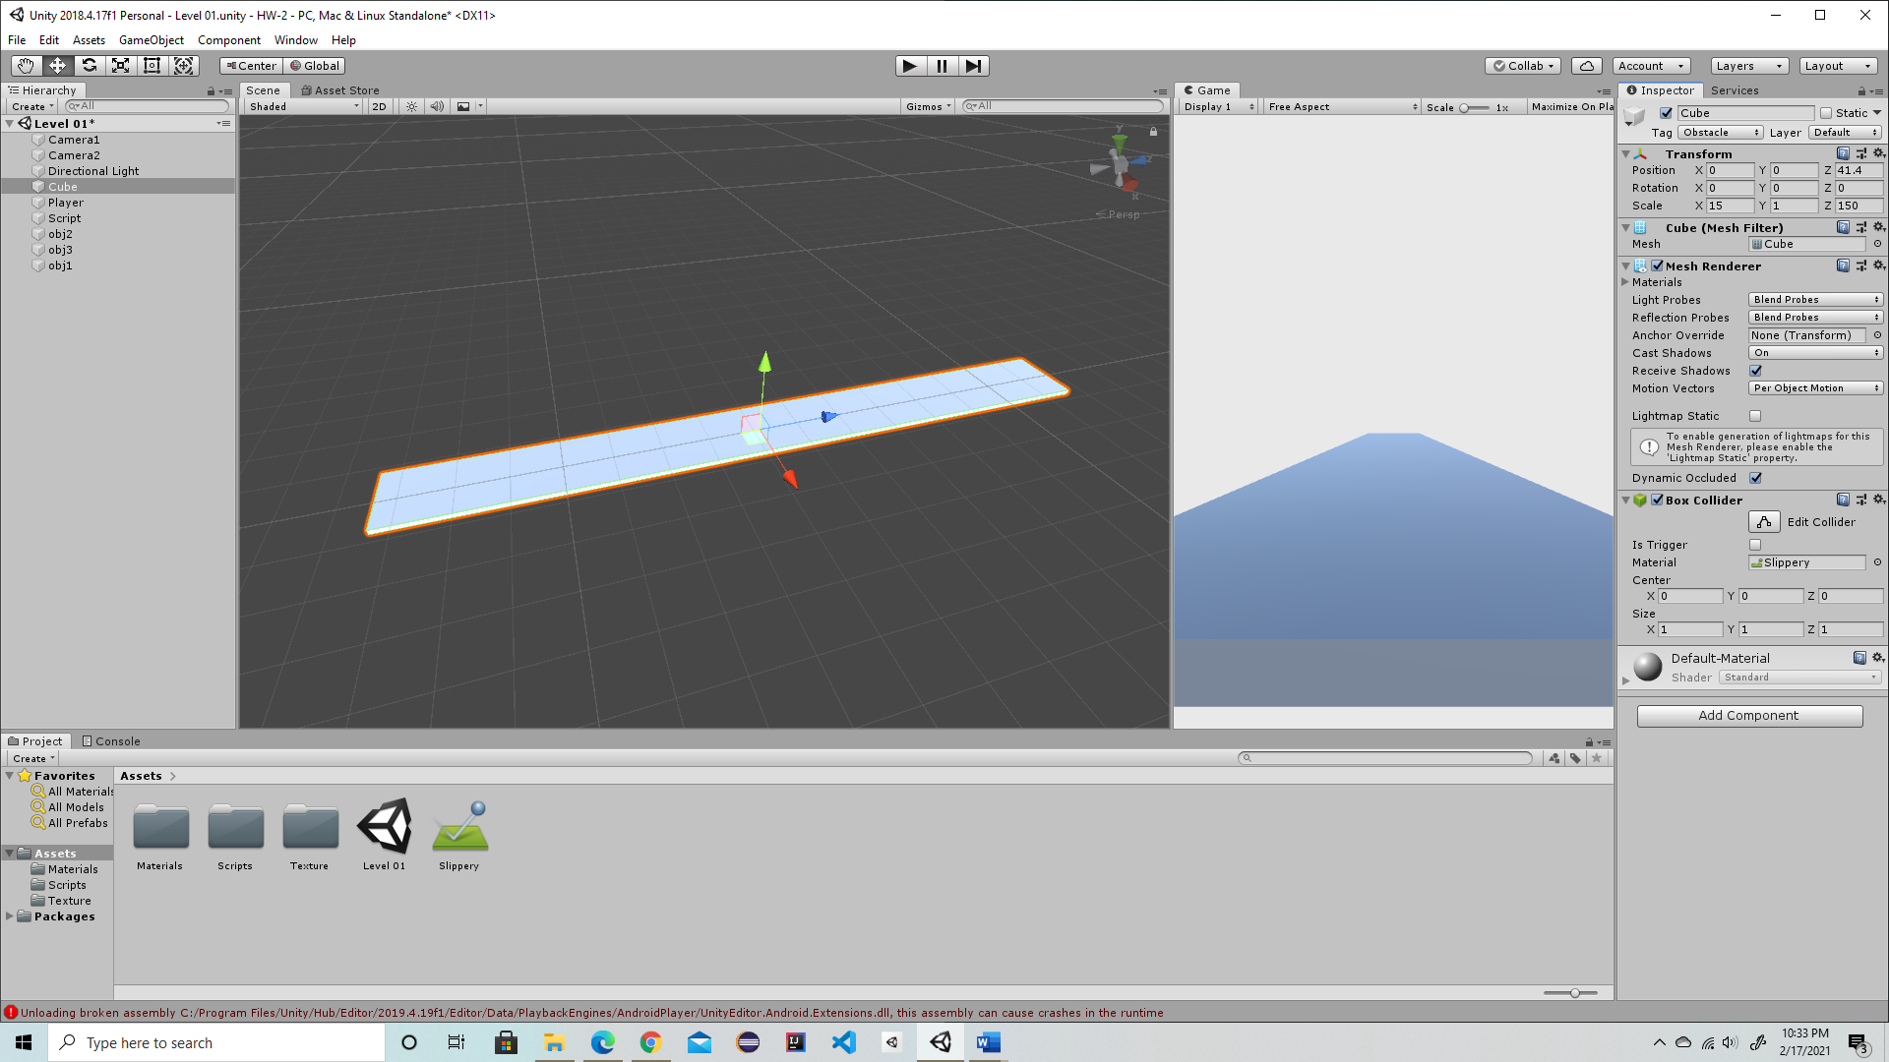

* Then I made a player out of a cube and color it red by using material option. You can move player left and right by using keys A and D.

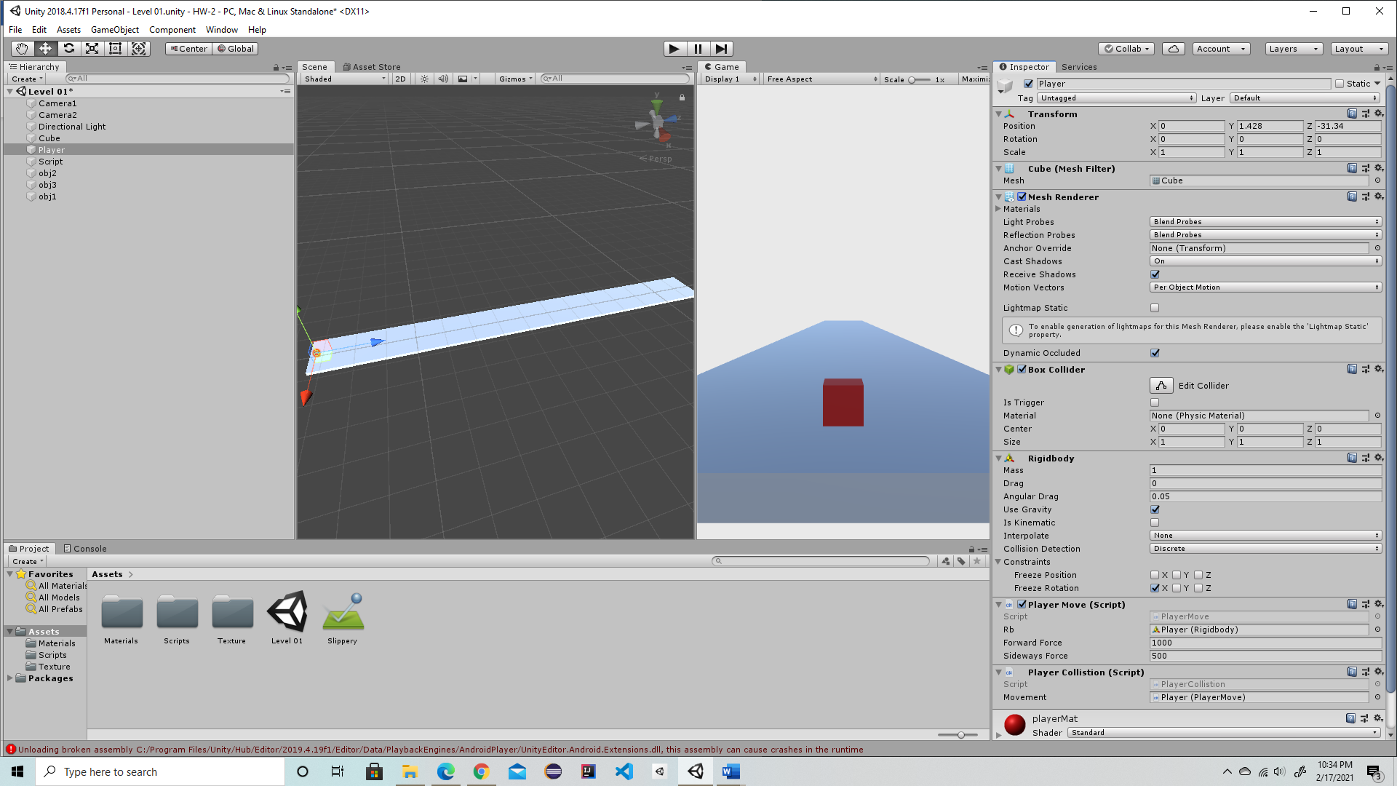

* After setting up the player and runway I created an object called obj1, obj2, and obj3. These objects are walls which stops the player if you collide.
* After setting up the objects, I setup the camera and position them. There are two camera called camera 1 and camera 2.
* Here is the Camera 1 view

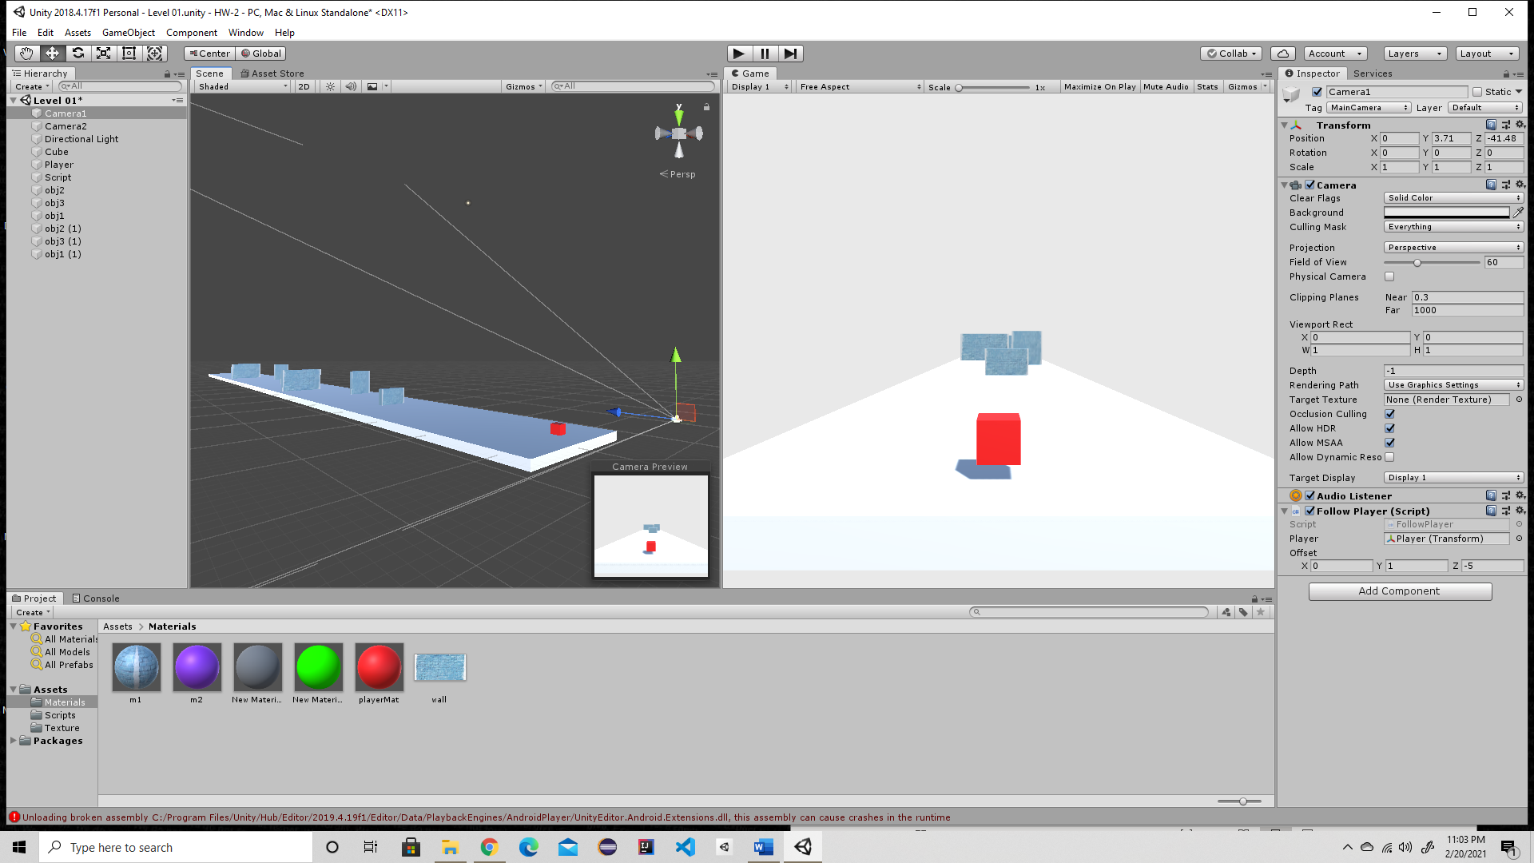

* To change the views of the camera I had to use a script which helps change the view.
* Here is the view of the second camera.

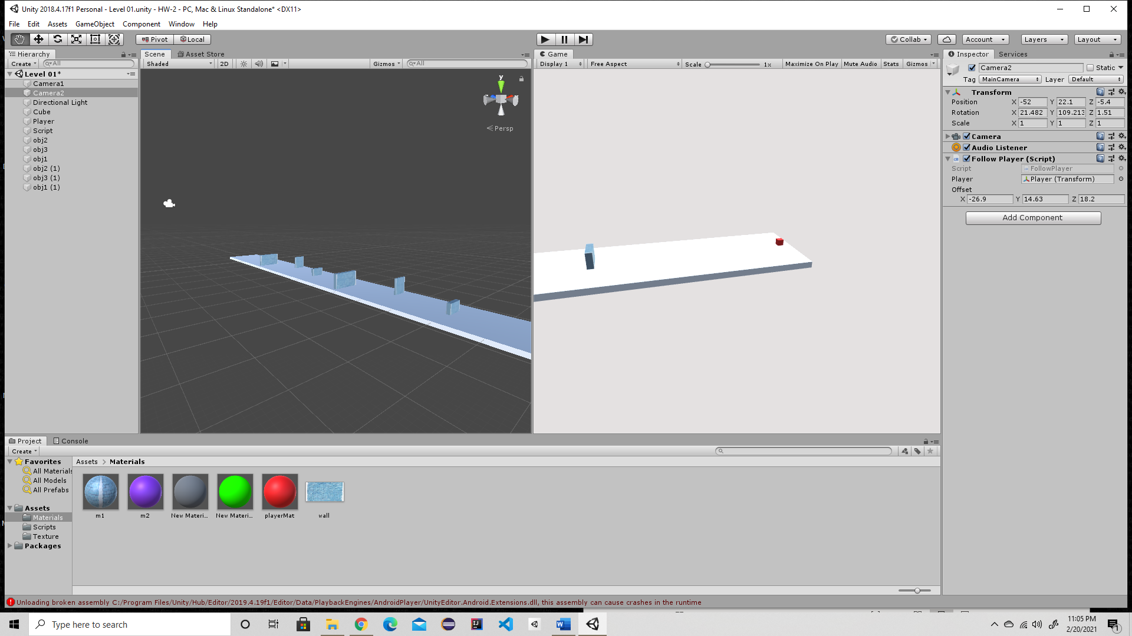

* To switch between cameras, you must press on Key C.
* Here is the screenshot of player colliding with walls,
* 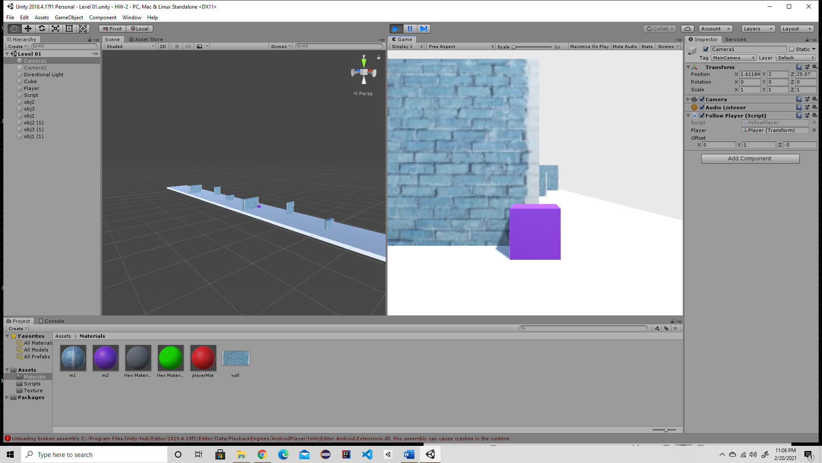



* To input a texture on the walls I had to pick the texture in the material. As shown in the pic

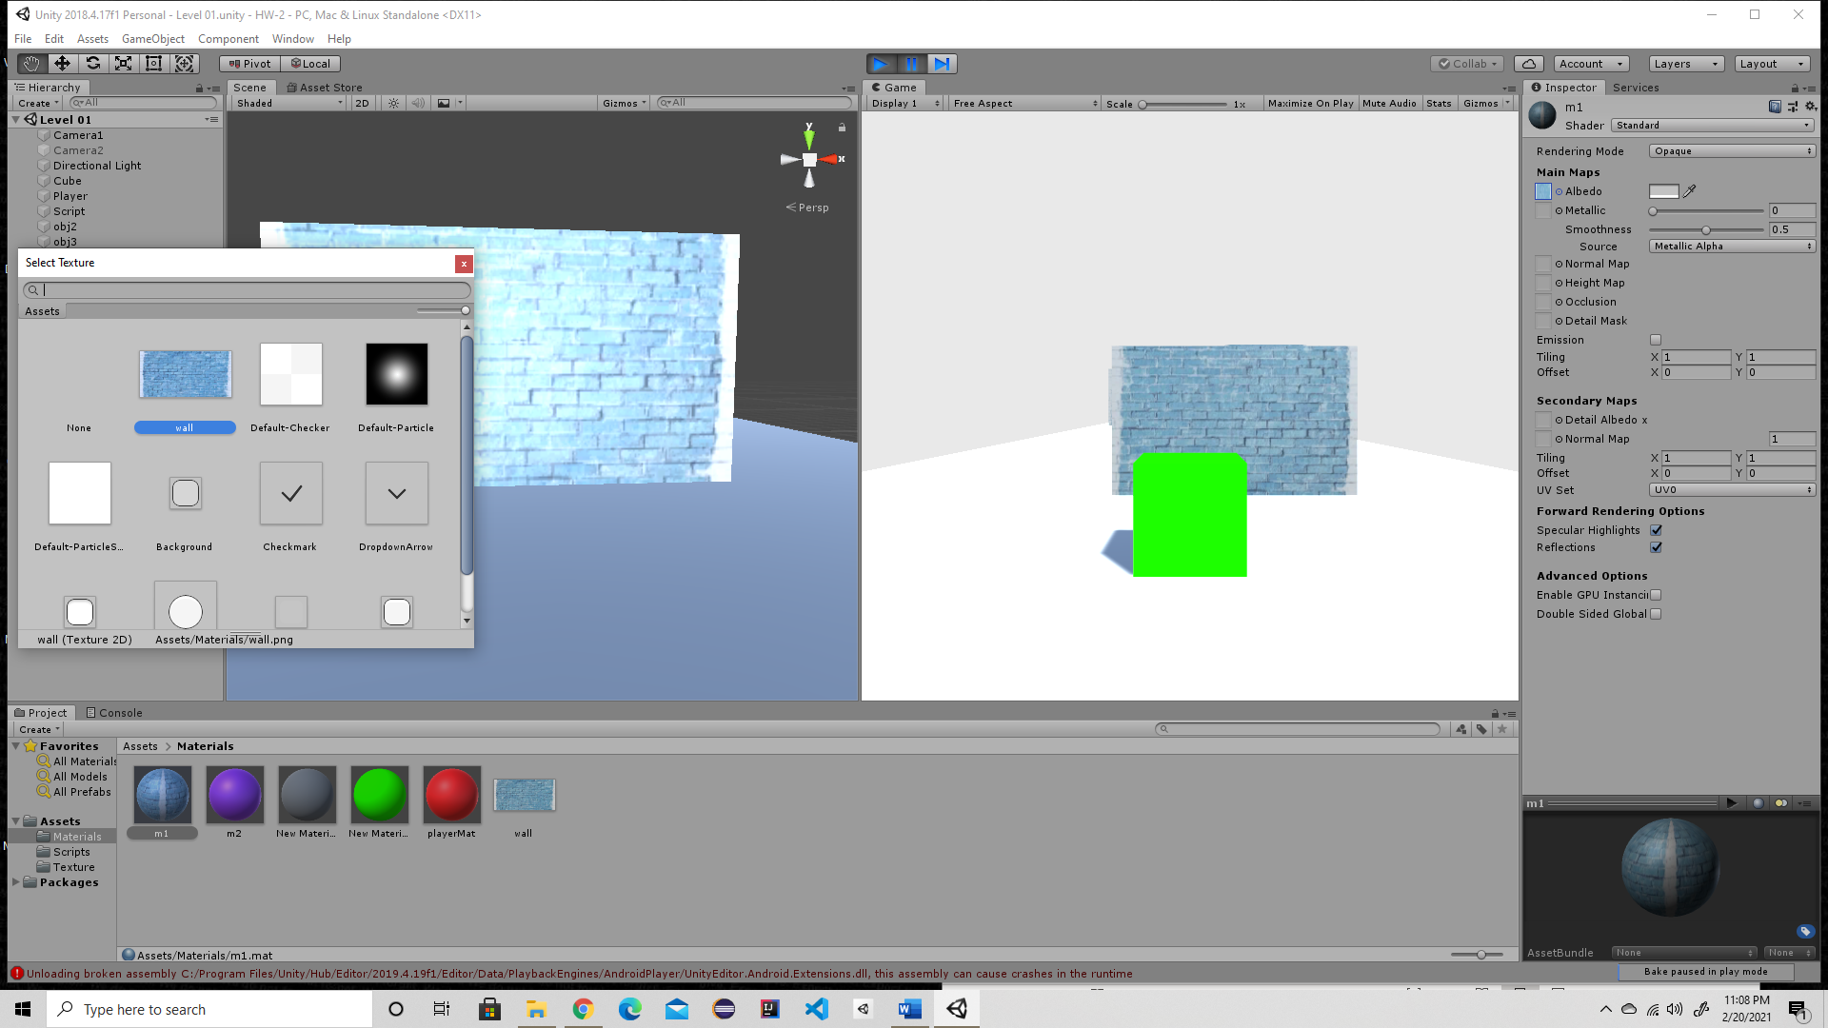



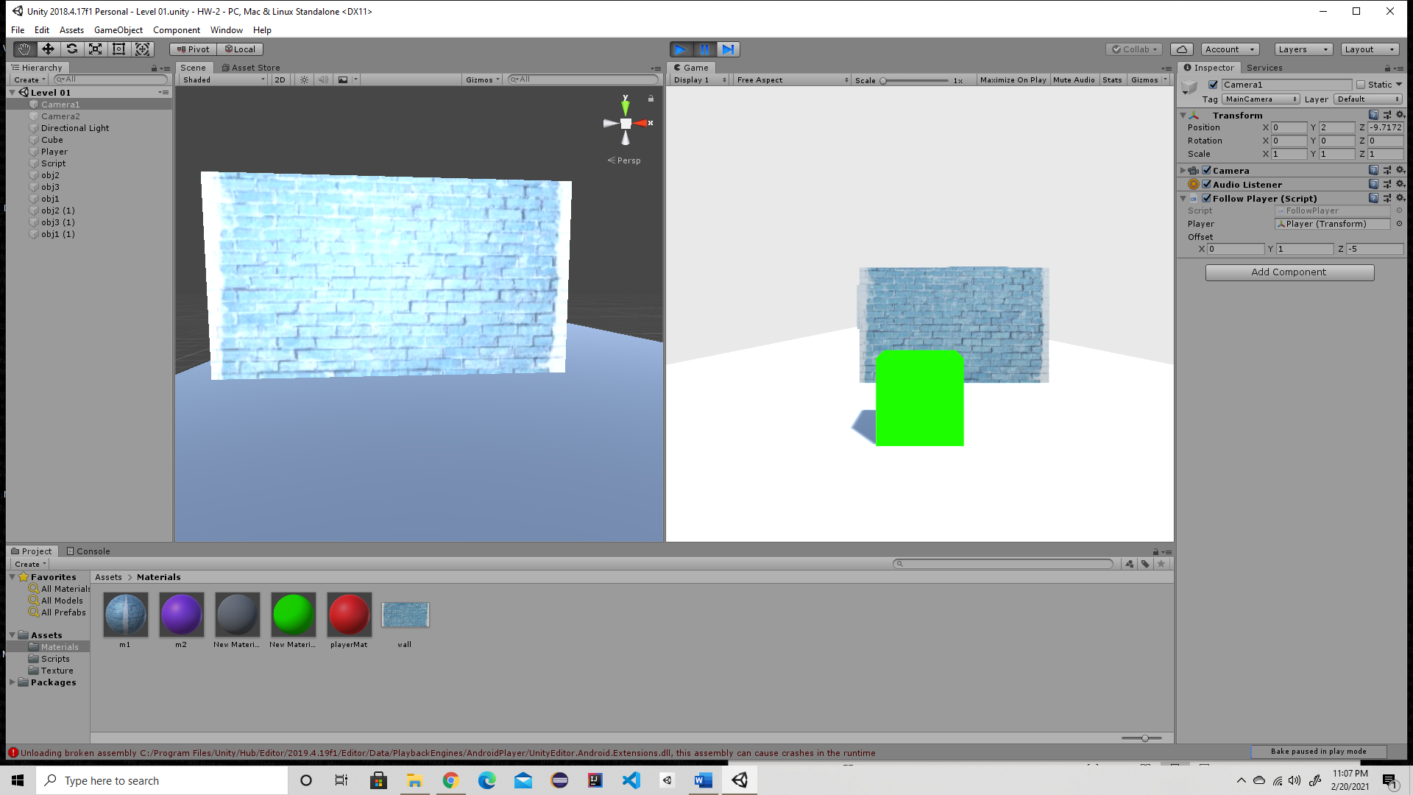

* The player change color on collusions as shown in the pictures.
* The color is purple before the player hit the ground.

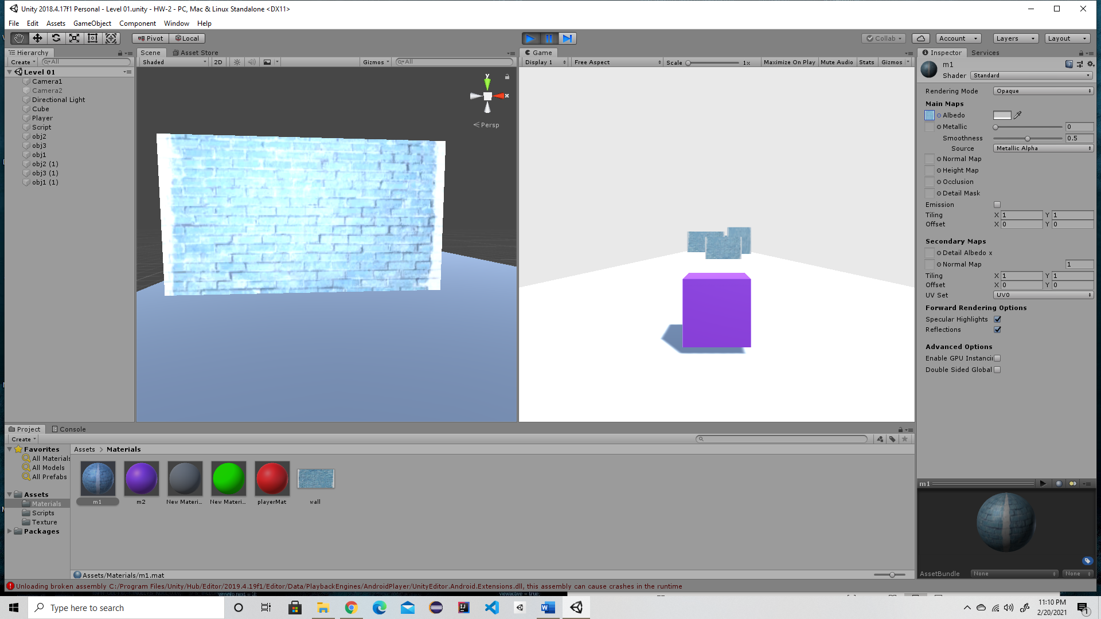

* The color change to green as the player hit the ground

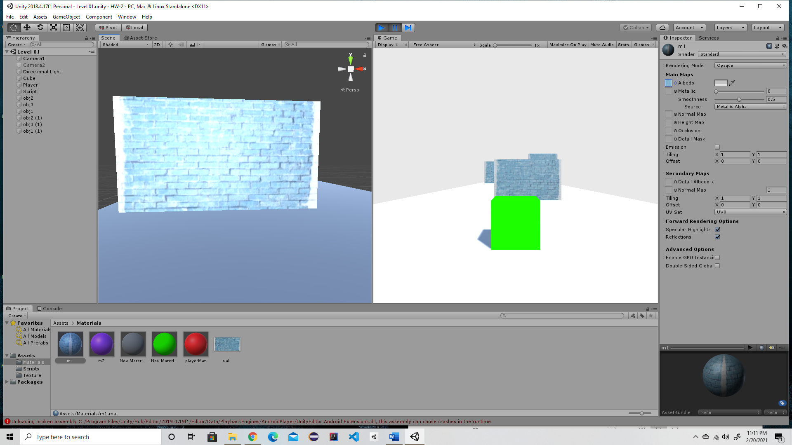

* And the color change to purple when the player collides with the wall.
* 